Odd or even

echo "enter a no: "
read n
temp=$(($n%2))
if [ $temp -eq 0 ]
then
echo "it is even"
else
echo " it is odd"
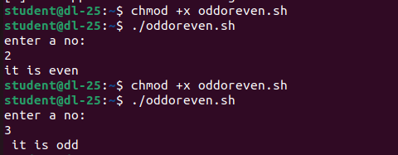
fi

